Online supplementary material

Table S1. Decayed, missing, or filled teeth (DMFT) score, by region and age group

 | DMFT score | 12-year-olds |  |  | 18-year-olds
 |  | Hordaland  (n = 137) | South region  (n=256) |  | Hordaland  (n = 165) | South region  (n = 147)
 | 0 | 102 (74.5) | 156 (60.9) |  | 41 (24.9) | 28 (19.1)
 | 1 | 18 (13.1) | 49 (19.2) |  | 26 (15.8) | 13 (8.8)
 | 2 | 10 (7.3) | 29 (11.3) |  | 23 (13.9) | 22 (14.9)
 | 3 | 4 (2.9) | 9 (3.5) |  | 32 (19.4) | 17 (11.6)
 | 4 | 3 (2.2) | 13 (5.1) |  | 9 (5.5) | 22 (14.9)
 | 5 | - | - |  | 7 (4.2) | 12 (8.2)
 | 6 | - | - |  | 7(4.2) | 10 (6.8)
 | 7 | - | - |  | 5 (3.0) | 5 (3.4)
 | 8 | - | - |  | 14 (8.5) | 9 (6.1)
 | 9 | - | - |  | 1 (0.6) | 4 (2.7)
 | 10 | - | - |  | - | 2 (1.4)
 | 11 | - | - |  | - | 3 (2.1)

Figure S1. Consumption frequency correlation matrix for eight relevant sugar-containing items in Norwegian diet by age group and region of residence
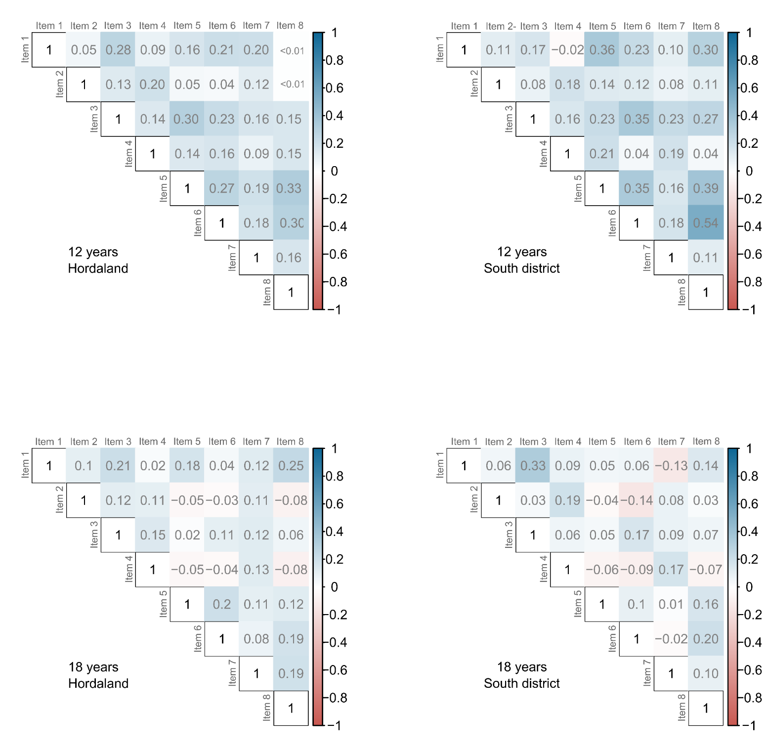
Item 1: chocolate milk; item 2: fruit yoghurt; item 3: chocolate spread; item 4: jam; item 5: biscuits and cakes; item 6: sweets; item 7: juice; item 8: soda

Figure S2. Distribution of consumption frequency score for sugar-containing items

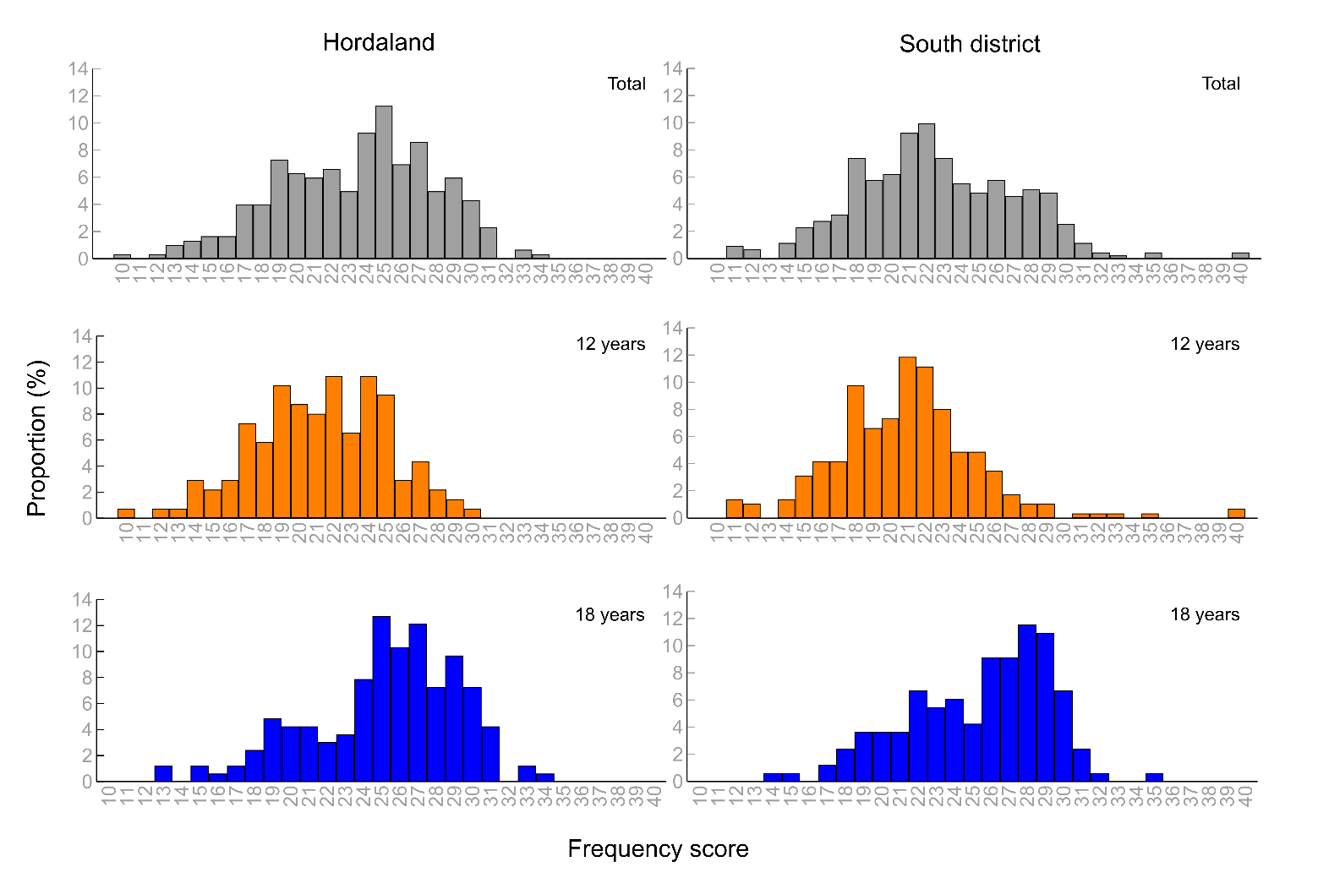

Figure S3. Distribution of number of sugar-containing items consumed frequently (≥3 times/week)

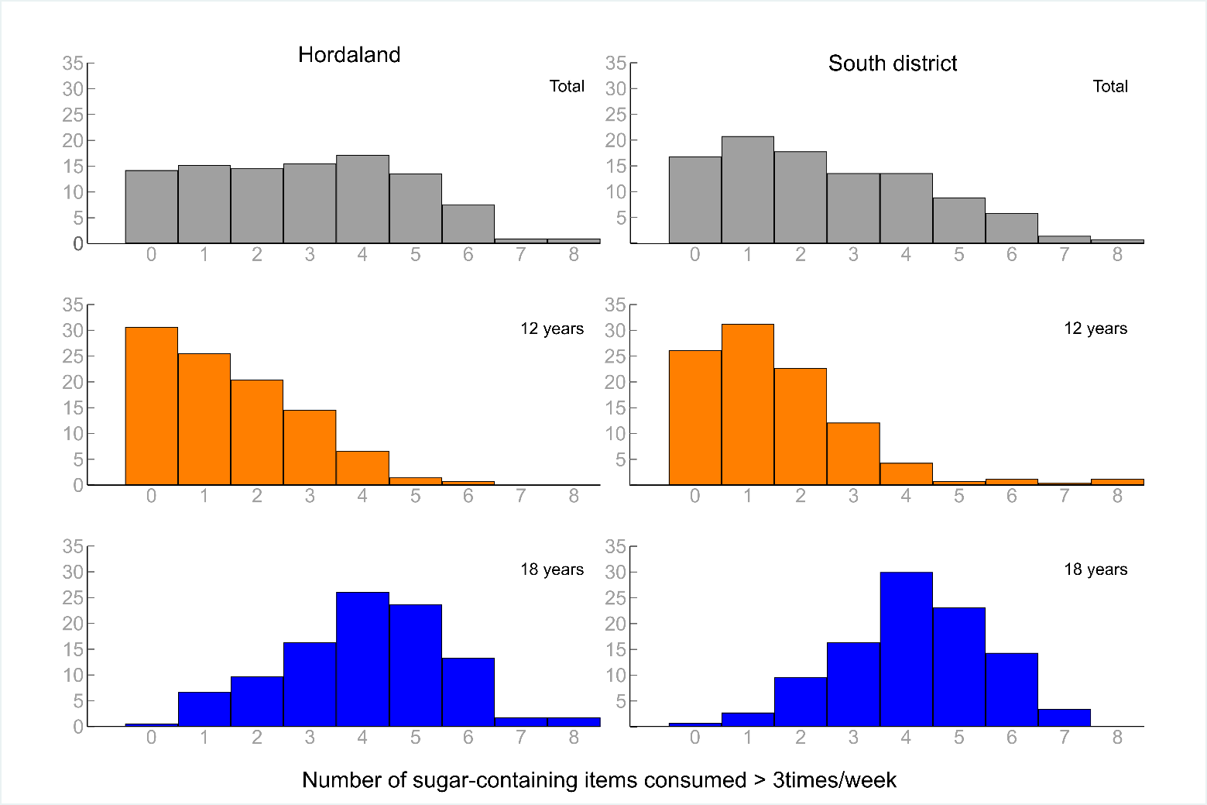

Table S2. Age group–specific regional differences in decayed, missing, or filled teeth (DMFT) score

 |  | All participants  OR (95% CI) |  |  | Participants with DMFT ≥ 1  IRR (95% CI)
 |  | 12-year-olds  (n = 393) | 18-year-olds  (n = 312) |  | 12-year-olds  (n = 135) | 18-year-olds  (n = 242)
District
 | Hordaland | 1 ^{reference} | 1 ^{reference} |  | 1 ^{reference} | 1 ^{reference}
 | South region | 1.87 (1.18 - 2.96) | 1.42 (0.82 - 2.44) |  | 1.12 (0.73 - 1.71) | 1.27 (1.05 - 1.53)
Sex
 | Male | 1 ^{reference} | 1 ^{reference} |  | 1 ^{reference} | 1 ^{reference}
 | Female | 1.43 (0.94 - 2.19) | 0.99 (0.56 - 1.73) |  | 1.23 (0.84 - 1.79) | 1.05 (0.86 - 1.29)
OR: odds ratio, estimated from logistic regression analyses with DMFT as a 2-category variable (0 vs. ≥1).
IRR: incidence rate ratio, estimated from zero-truncated negative binomial regression analyses (with DMFT as discrete variable with 10 categories).

Table S3. Regional differences in teeth-brushing habits and fluoride intake: age group–specific analyses

 |  | 12-year-olds |  |  | 18-year-olds
 |  | Hordaland  (n = 137) | South region  (n = 256) |  | Hordaland  (n = 165) | South region  (n = 147)
Brushing teeth, %
 | < twice/day | 25.7 | 25.8 |  | 33.9 | 35.3
 | Twice/day | 74.3 | 74.3 |  | 66.1 | 64.6
Odds ratio (95% CI)† |  | 1.01 (0.64 - 1.54) |  |  | 0.94 (0.68 - 1.32)
Fluoride use, %
 | No/never | 2.2 | 7.4 |  | 18.8 | 22.5
 | < 1 year | 15.3 | 16.0 |  | 22.4 | 23.1
 | 1–3 years | 40.2 | 36.4 |  | 26.1 | 29.9
 | ≥ 4 years | 42.3 | 40.2 |  | 32.7 | 24.5
Odds ratio (95% CI)‡ |  | 0.78 (0.52 - 1.19) |  |  | 1.01 (0.64 - 1.54)
† Estimates from logistic regression analyses, adjusted for sex
‡ Estimates from ordered logistic regression analyses, adjusted for sex

Table S4. Regional differences in consumption of drinks with added sugar* during and between meals: age-specific analyses

Drinks with added sugar |  | 12-year-olds |  |  | 18-year-olds
 |  | Hordaland  (n = 137) | South region  (n = 256) |  | Hordaland  (n = 165) | South region  (n = 147)
During meals, %
 | No | 83.1 | 86.0 |  | 72.7 | 78.9
 | Yes | 16.9 | 14.0 |  | 27.3 | 21.1
Odds ratio (95% CI)† |  | 0.81 (0.46 - 1.44) |  |  | 0.70 (0.41 - 1.19)
Between meals, %
 | No | 86.7 | 87.8 |  | 79.4 | 80.3
 | Yes | 13.3 | 12.2 |  | 20.6 | 19.7
Odds ratio (95% CI)† |  | 0.90 (0.58 - 1.40) |  |  | 0.94 (0.67 - 1.32)
* Juice, coffee or tea with sugar, soda, and other sugar-containing beverages
† Estimates from logistic regression analyses, adjusted for sex.

Table S5. Regional differences in consumption patterns of relevant sugar-containing items: age group–specific analyses

 |  | 12-year-olds |  |  | 18-year-olds
 |  | Hordaland  (n = 137) | South region  (n = 256) |  | Hordaland  (n = 165) | South region  (n = 147)
Frequency score, median (range) |  | 21  (10 - 30) | 21  (11 - 40) |  | 26  (13 - 34) | 26  (14 - 35)
Incidence rate ratio (95% CI) |  | 0.98 (0.96 - 1.02)† |  |  | 1.01 (0.99 – 1.01)†
Number of items consumed ≥ 3 times/week,  median (range) |  | 1  (0 - 6) | 1  (0 - 8) |  | 4  (0 - 8) | 4  (0 - 7)
Incidence rate ratio (95% CI) |  | 1.02 (0.82 - 1.30) † |  |  | 1.03 (0.96 - 1.10) †
Frequent use of (any) item, %
 | No | 30.4 | 26.1 |  | 0.6 | 0.7
 | Yes | 69.3 | 73.8 |  | 99.4 | 99.3
Odds ratio (95% CI) |  | 1.25 (0.74 - 2.13)‡ |  |  | 0.90 (0.07 - 10.69)‡
† Estimates from negative binomial regression, adjusted for sex
‡ Estimates from logistic regression analysis, adjusted for sex

